27 St Michaels Rd
Tamboerskloof
8001
10 January 2013

Dear Editor,

Re: Anaesthesia and the Paediatric Muscle Disorders

I hereby give permission for the publication of the above paper in SAJAA and online at www.sajaa.co.za. I furthermore grant copyright of the material to SASA and declare that no copyright infringement or plaigirism has taken place in the preparation f the paper. I have not submitted this paper elsewhere. I have no conflict of interest to declare.

Yours faithfully,
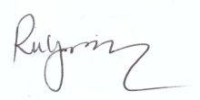
Dr Rebecca Gray

rebecca.gray@uct.ac.za
0214236648
0845033617

